*LAB # 01*

INTRODUCTION TO STRING POOL,LITERALS, AND WRAPPER CLASSES

# *OBJECTIVE:*

*To Study the concepts of String Constant Pool, string literals, String Immutability and Wrapper Classes.*

*LAB task*

1. *Write a program that initialize five different strings using all the above mentioned ways, i.e., a)string literals b)new keyword also use intern method and show string immutability.*

**Code:**

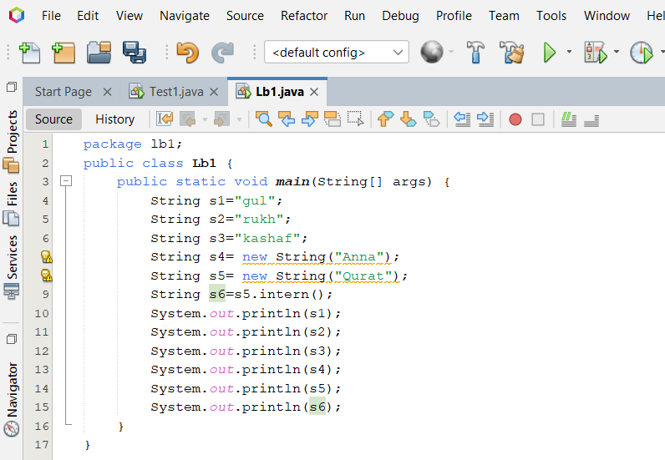

**Output:**

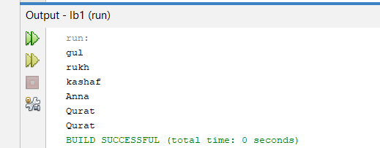

1. *Write a program to convert primitive data type Double into its respective wrapper object.*

**Code:**

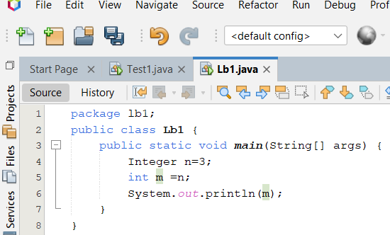

**Output:**

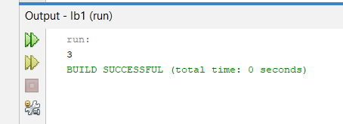

*3. Write a program that initialize five different strings and perform the following operations.*

*a. Concatenate all five stings.*

*b. Convert fourth string to uppercase.*

*c. Find the substring from the concatenated string from 8 to onward*

**Code:**

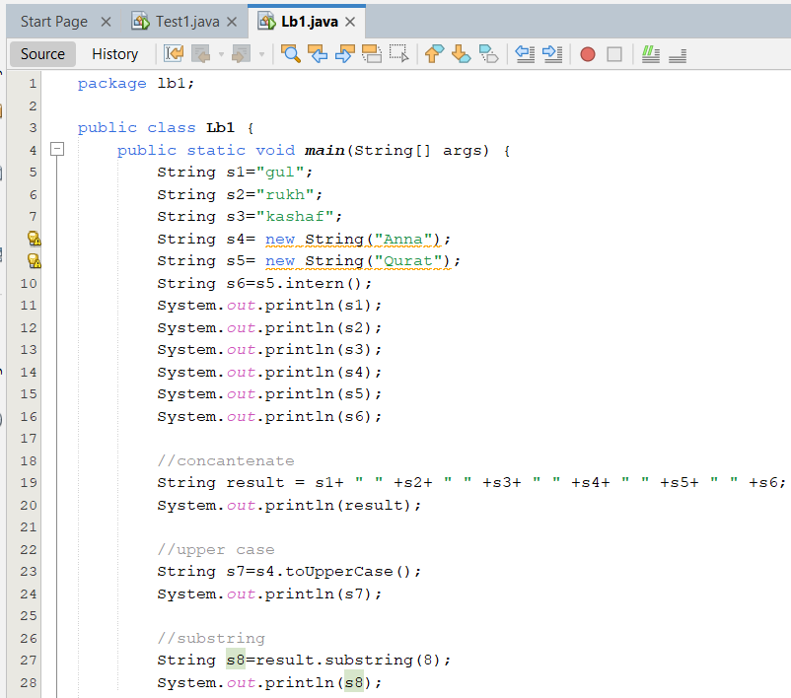

**Output:**

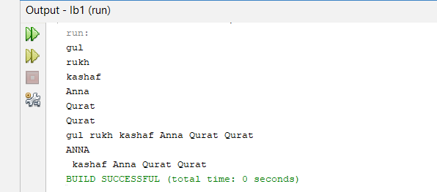

***4*** *.You are given two strings word1 and word2. Merge the strings by adding letters in alternating order, starting with word1. If a string is longer than the other, append the additional letters onto the end of the merged string. Return the merged string.*

*Example: Input: word1 = "abc", word2 = "pqr" Output: "apbqcr"*

*Explanation: The merged string will be merged as so: word1: a b c word2: p q r merged: a p b q c r*

**Code:**

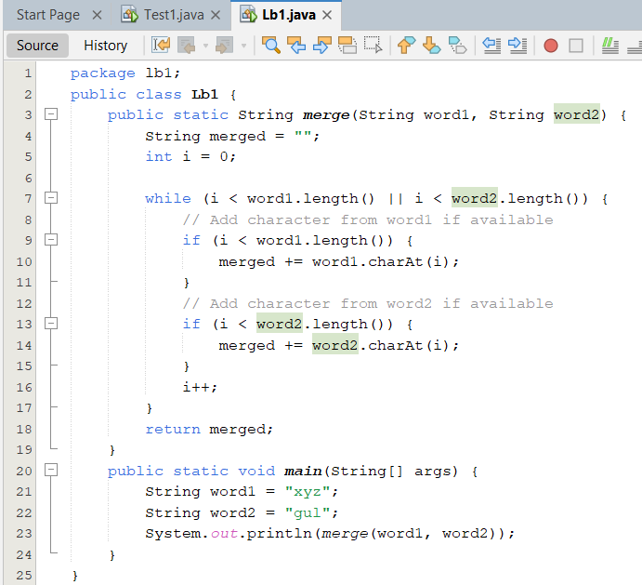

**Output:**

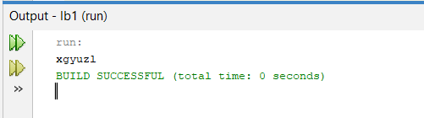

*5. Write a Java program to find the minimum and maximum values of Integer, Float, and Double using the respective wrapper class constants.*

**Code:**

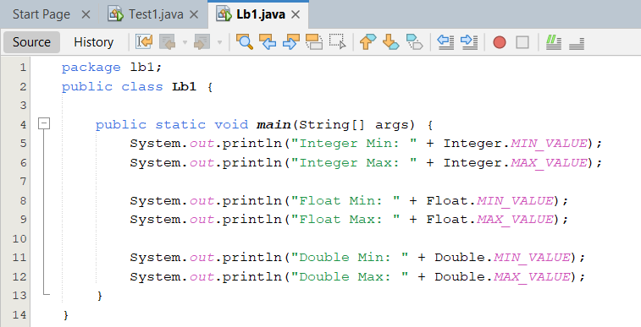

**Output:**

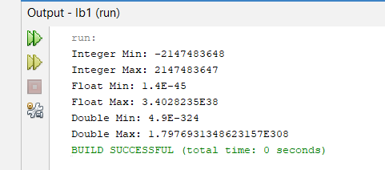

*home task*

1. *Write a JAVA program to perform Autoboxing and also implement different methods of wrapper class.*

**Code:**

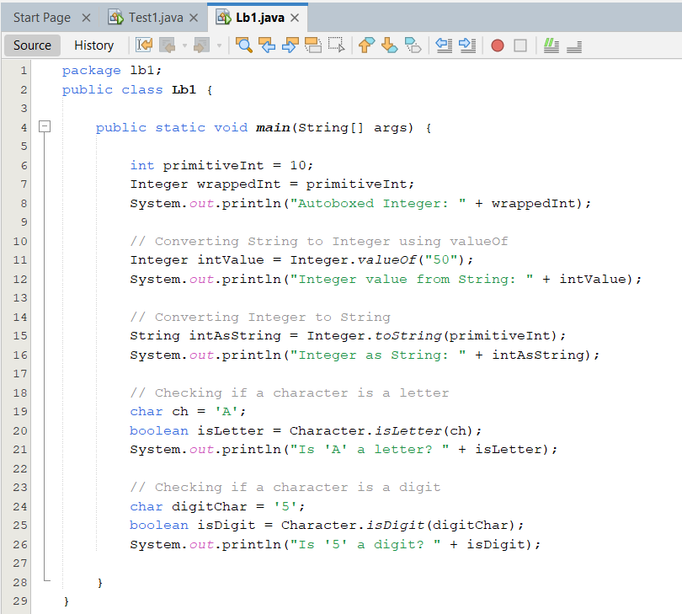

**Output:**

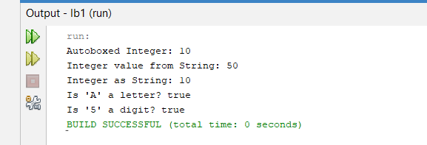

1. *Write a Java program to count the number of even and odd digits in a given integer using Autoboxing and Unboxing.*

**Code:**

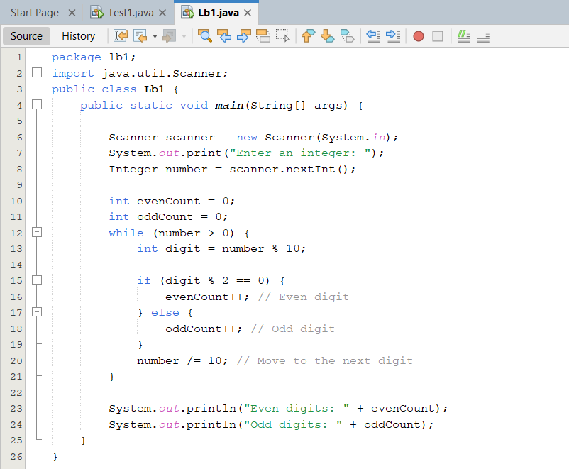

**Output:**

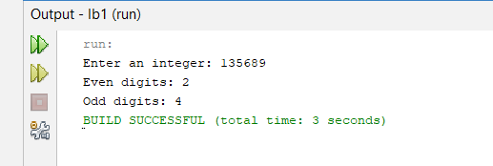

1. *Write a Java program to find the absolute value, square root, and power of a number using Math class methods, while utilizing Autoboxing and Wrapper classes.*

**Code:**

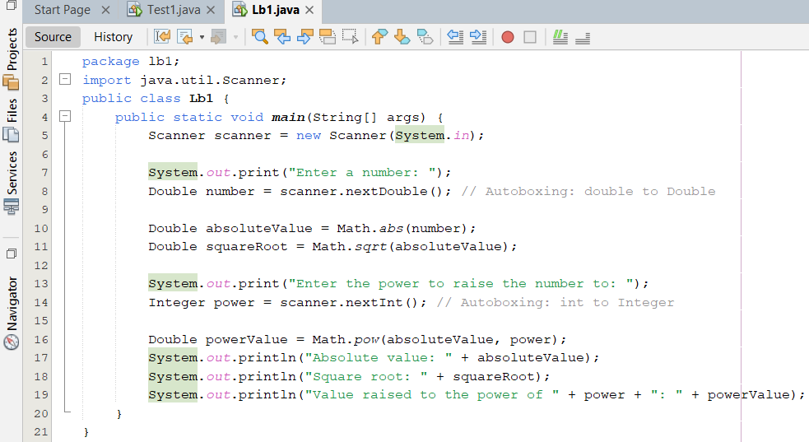

**Output:**

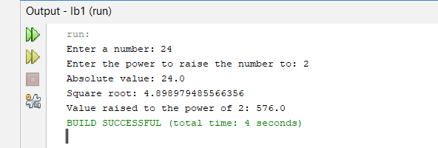

1. *Write a Java program to reverse only the vowels in a string.*

**Code:**

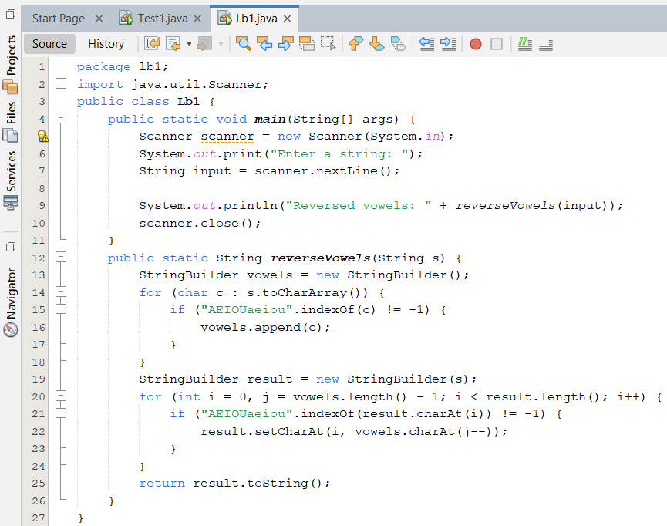

**Output:**

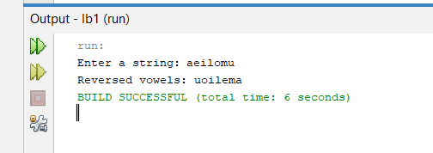

1. *Write a Java program to find the longest word in a sentence*

**Code:**

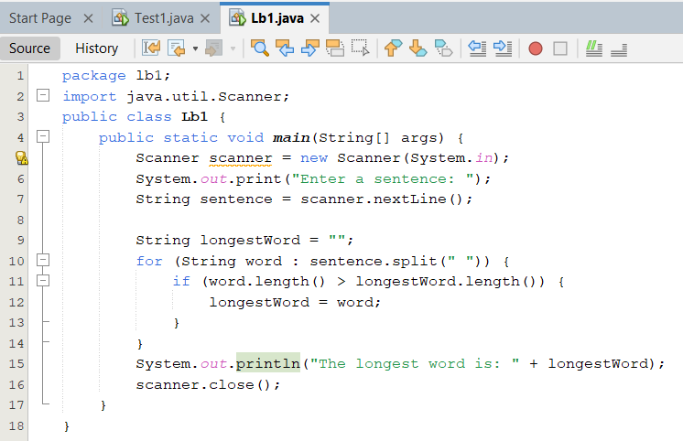

**Output:**

